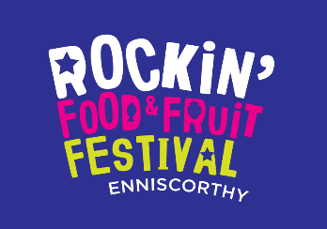


Campervan & Camping Facilities
Enniscorthy Rockin’ Food & Fruit Festival 2022

Enniscorthy will be alive with a huge choice of Free Live Music Gigs all weekend, Artisan Food, Craft & Beer Markets, Food & Drink
Events/Demos and Lots of Family Fun and Amusements.

Details:
Dates: Friday July 29th — Monday August 1st (August Bank Holiday Weekend).
Camping Venue: Ajax Athletic AFC,
Patrick Mernagh Park, Daphne View,
Enniscorthy, Co. Wexford. Y21 DX09
Fee (for the duration of your stay over the weekend, 1 or 3 nights):
- €90 per Campervan/Caravans.
(Campervans/Caravans parked at owners’ risk.)
- €45 per Tent.


Facilities available Include;
- Ample parking.
- Secure and fully insured site.
- Showers, toilets, basic kitchen facilities and electrical connection.
- Waste Disposal.
Booking + Payment

- PayPal: www.paypal.me/GreyThunder
- Bank Transfer: Account Name: Fran Farnan
        - IBAN: IE63AIBK93341404759192
        - BIC: AIBKIE2D
        - Sort code: 93-34-14
- At the Gate from 12 noon, Friday 26th July.

